**Online diary**

**Task-Skill and chance Noughts and Crosses**

**3.0 Introduction**

The task that was set this week was for us to modify noughts and crosses by adding an element of chance. We were not allowed to just add a dice or cards; we had to make it fun for adults as well. I suggested to add dice to noughts and crosses but the ultimate version. The ultimate version uses a a big 3 by 3 grid, but has 3 by 3 grids in each slot. Both players start in the middle nut dpending on where you put it in that grid is where the other player moves to.

**3.1 Materials**

Dice with 9 faces

Paper

2 pencils

A coloured pencil

**3.2 Game idea**

As mentioned, before we added a dice to ultimate noughts and crosses, however we wanted to add something else as well. Since we used ultimate noughts and crosses we got away with just adding a dice however we wanted to test what else we could to make the game more challenging. We ended up adding a double space square. This would mean players could have an additional turn if they added their mark to this space. This meant it added more challenge to the game itself.

**3.3 Rules**

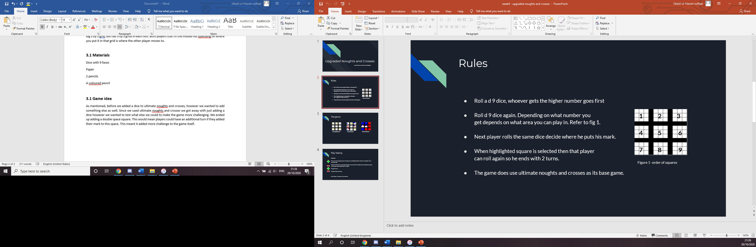

The rules of the game are quite simple. To start both players roll a D9 dice. Which player gets the higher number gets to go first. After the order of turns is decided both players have 2 double spaces each, they get to decide where these spaces go. They would highlight these spaces with a different colour that they are both using.

The player who rolled the higher number will roll again. Depending what number, they rolled on the D9 dice depends on which game they get to play on. For example, if they rolled a 4, they would go to the 4th grid and but there mark somewhere on that gird. Both players will continue to do this throughout the game. If a highlighted square is marked then that player ho marked it gets to go again by rolling the D9 dice.

The player wins once they have won three games in a row like a normal noughts and crosses’ game, but across nine grids. The below figures show how the game will play out from start to finish.

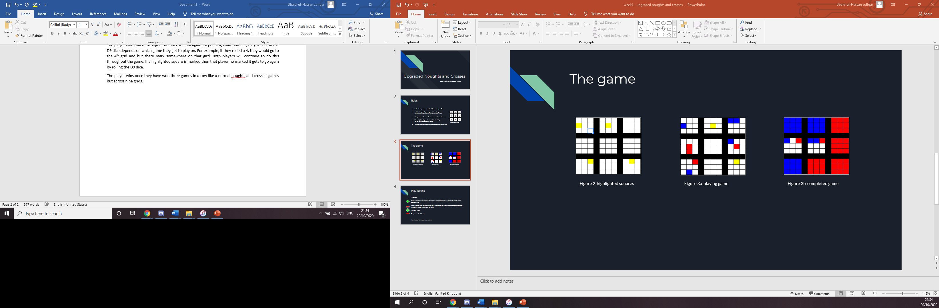

**3.4 Playtesting**

Believe it or not we began playtesting first, among our group that is. The dice mechanic was not actually added until after the first playtesting, at first it was just the double space. After play testing without a dice we came to decision to add the dice as we wanted to add more chance element to the game.

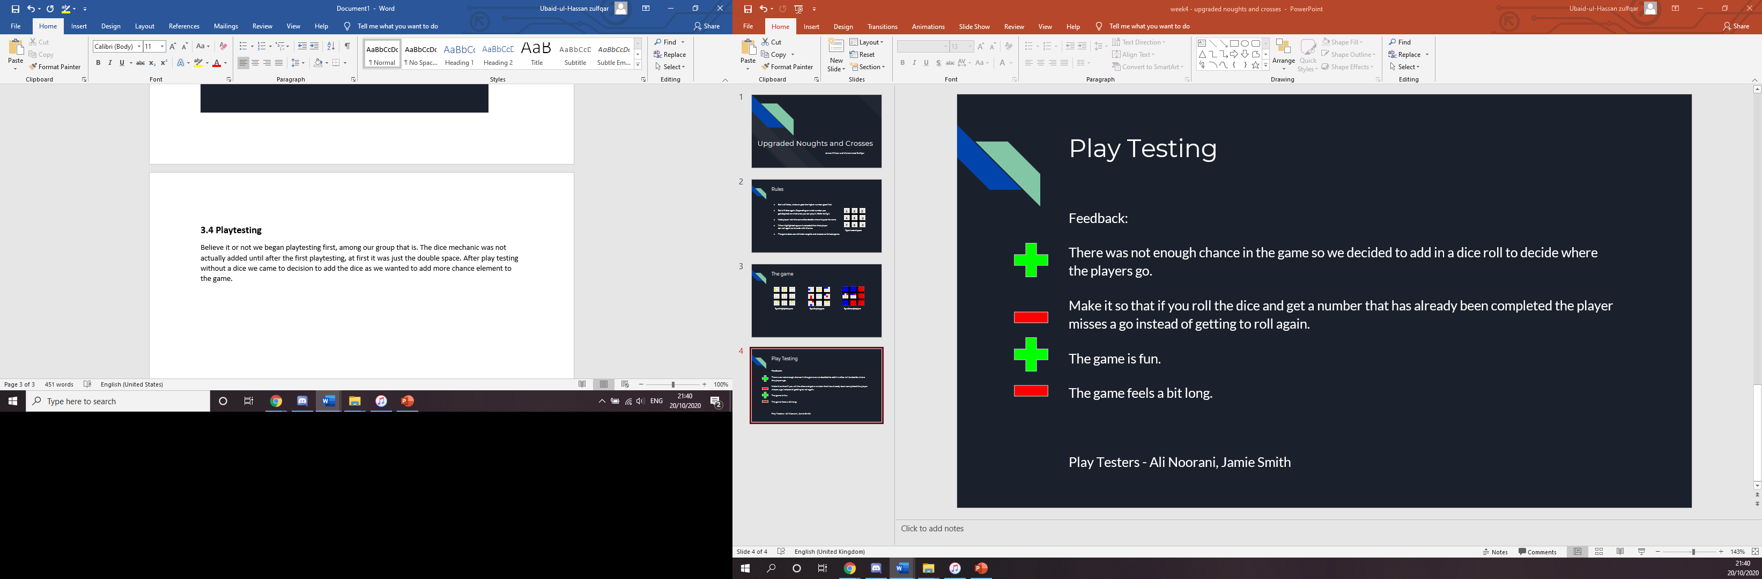

We managed to play test with another group this time. They said they game was really fun to play but took to long. Me and James thought about adding so if someone rolled a number but that square was taken that player misses their go however that idea was scrapped as the play testers said that would make the game annoying.

**3.5 Reflection**

This was the second week in a row where me and James worked together and we do make a good team. We were able to express our ideas openly and freely and wouldn’t really change the game that much. I would change a bit about how I present and the presentation though. Next time I want to be able to present in front of the class without getting stage fright and be able to label my images right. I would also like to test myself and be to create something that will knock everyone’s socks off.

